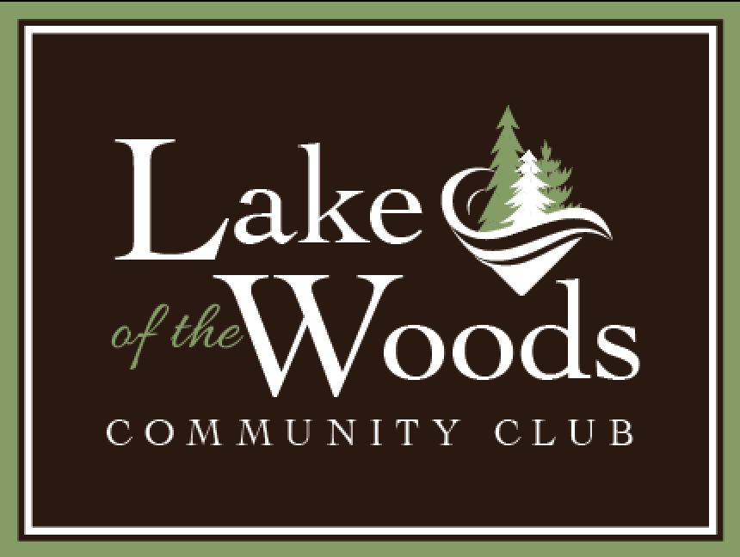
Lake of the Woods Community Club
P.O. Box 579
Wauna, WA 98395

“A Refreshing Place to Live”

Hello New Property Owners and Neighbors! Community Website WWW.lakeofthewoodskpn.com

This is a letter to welcome you, and provide you information about our Community. We are happy you have decided to join the community and encourage you to check our website for events, updates, special notes, and to find any documents you might need.

In case you did not get these documents from your Escrow Officer, we have enclosed copies of the Lake of the Woods Community Club’s governing documents:
- Certificate of Existence/Authorization of Lake of the Woods Community Club;
- Articles of Incorporation;
- Amended Bylaws
- Protective Covenants and Restrictions;
- Architectural Committee Declaration;
- Rules, Regulations and Fees for Water Distribution and Service and Community Property Maintenance; and
- Standards for Lake of the Woods’ Common Areas.

We are a covenant community and all community members are mandated to comply with the provisions of the governing documents. Please read them carefully and keep them available for referral. It is especially important that you read all the documents before beginning any remodeling of your property and/or adding any fences, patios, garages, sheds, etc. Remodeling and/or additions to your property must be approved by the Architectural Committee prior to beginning.

For 2024 our Community Club has general and special assessments totaling $605.87 per year per lot, which equates to $50.49 a month from January to December. If you have any questions regarding the general annual assessment or the special assessments, please call any of our directors.

Our Community Club’s regular monthly meeting is at 6:00 p.m. on the second Monday of each month at Key Peninsula Civic Center - 17010 South Vaughn Rd NW, Vaughn, WA 98394. We encourage you to attend so you are aware of what goes on in our community. Our Annual Meeting and will be November 2nd from Noon until 2 pm.

If you need any information or have any questions, please do not hesitate to contact any of our Officers and/or Directors. For your convenience the names and telephone numbers are listed below. You may also contact us through our website: lakeofthewoodskpn.com. Thank you and welcome to our Community!

Karen Gore, President (425) 761-3632 Katelynn Graham (360) 265-8960

David Tyler, 1st Vice Pres. (Water) (253) 732-3683 Frank Benson (928) 897-0761
Garrett Lebby (520) 370-2496
Barbara Dommert-Breckler, (253) 468-1901
Treasurer
Anna Hernandez-French, (707) 599-9591
Secretary

Architectural Committee:
Ryan Orseth (360) 731-9672
Philip Henry (603) 852-0426
Alex Graham (509)339-5368

